Plants vs Zombies  
Report

Member:

Nguyễn Đình Minh Phúc – ITITUN17003

I/ Introduction

II/ Functions

III/ Demonstration

IV/ References

I/ Introduction

*Plants vs. Zombies* is a [tower defense](https://en.wikipedia.org/wiki/Tower_defense) and [strategy](https://en.wikipedia.org/wiki/Strategy) [video game](https://en.wikipedia.org/wiki/Video_game) developed and originally published by [PopCap Games](https://en.wikipedia.org/wiki/PopCap_Games" \o "PopCap Games) for [Windows](https://en.wikipedia.org/wiki/Windows) and [OS X](https://en.wikipedia.org/wiki/OS_X) in May 2009, and ported to consoles, handhelds, mobile devices, and remastered versions for personal computers.

In *Plants vs. Zombies*, the player takes the role of a homeowner in the midst of a [zombie apocalypse](https://en.wikipedia.org/wiki/Zombie_apocalypse). To defend their home from zombies, some of which have unique abilities, the player uses plants that can fire projectiles at, or have other detrimental effects on, the horde of advancing zombies. The player collects "sun" with which defending plants can be bought. Zombies approach along several parallel lanes on the lawn and the player must plant defenses in these lanes. If a zombie makes it to the house on any lane, the level is over.

II/ Functions

Most of functions in this project requite mouse control so MouseListener is essential

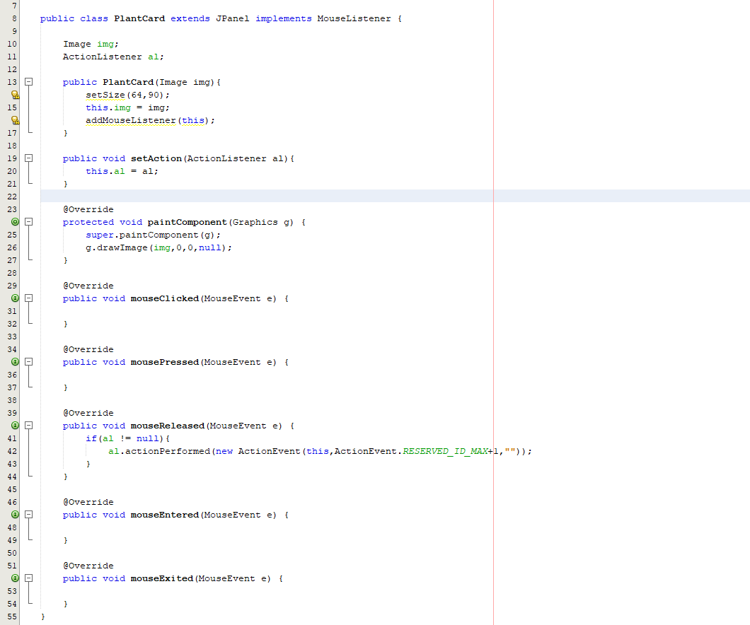

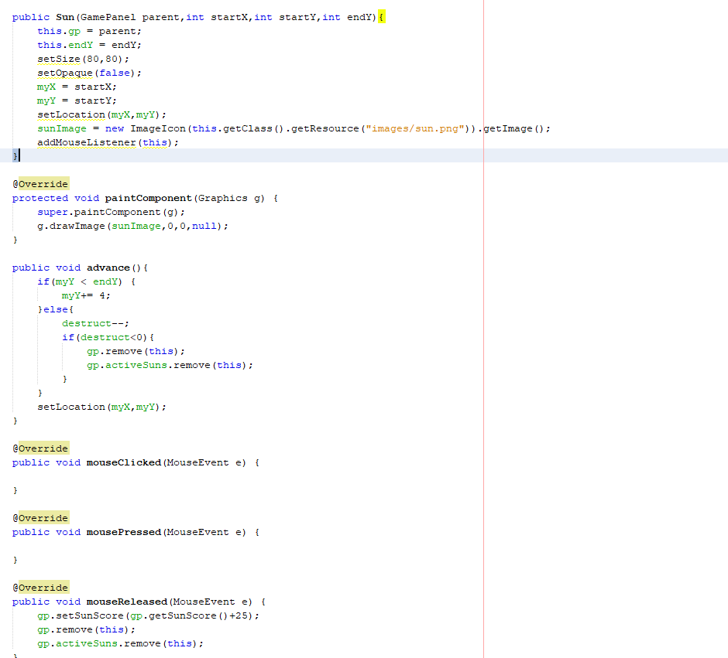

Plant functions:

Peashooter

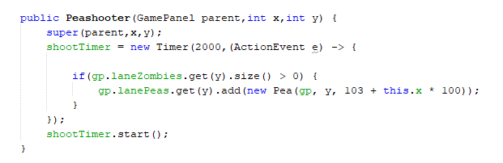

Pea  
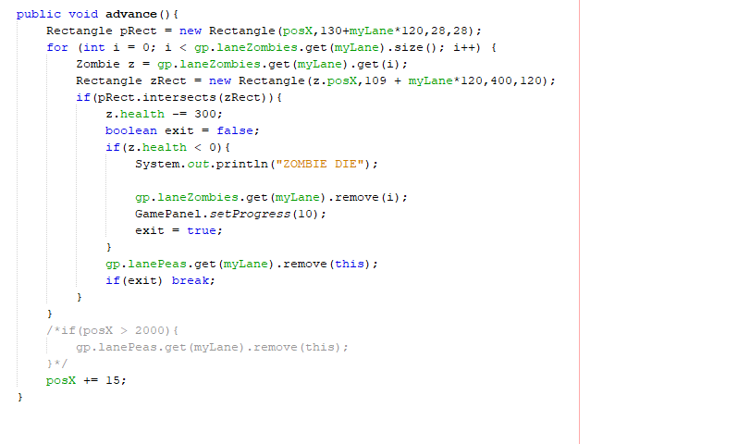

FreezePea

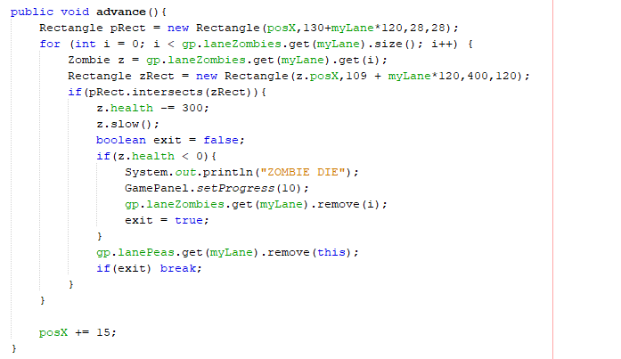  
Zombie

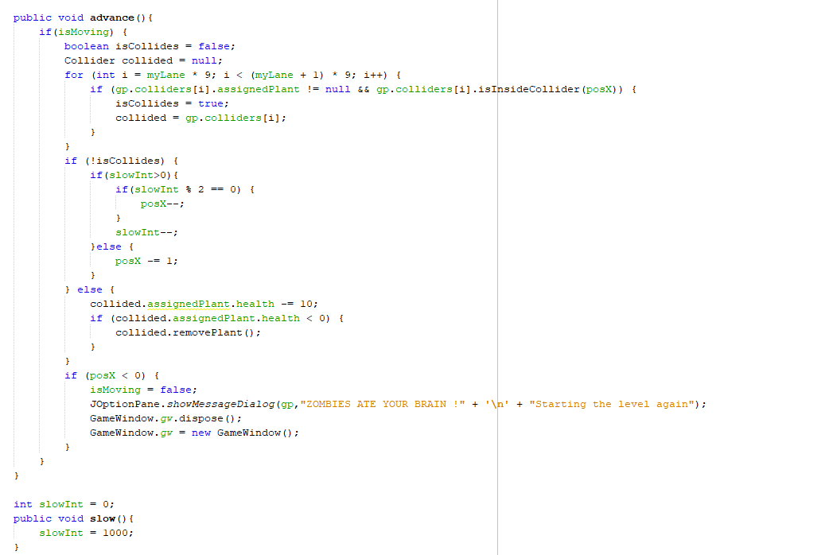

Setbacks in this project:

* No proper UI.
* Only few type of both plants and zombies.
* There are only two stages.
* Only few animations in the project

III/ Demonstration

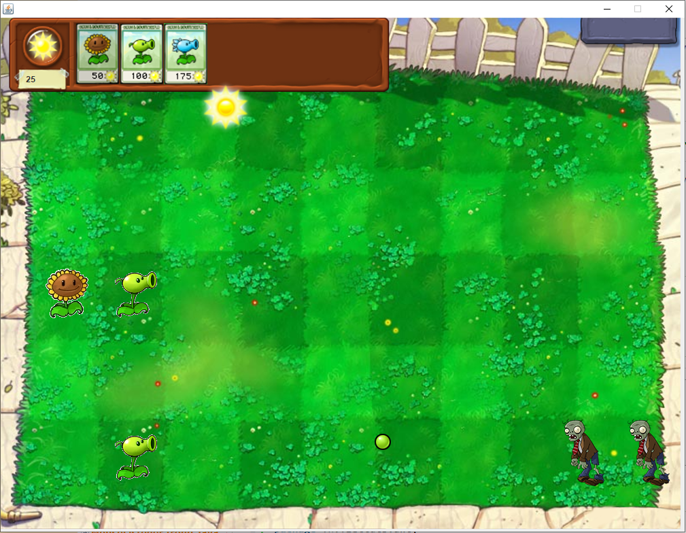

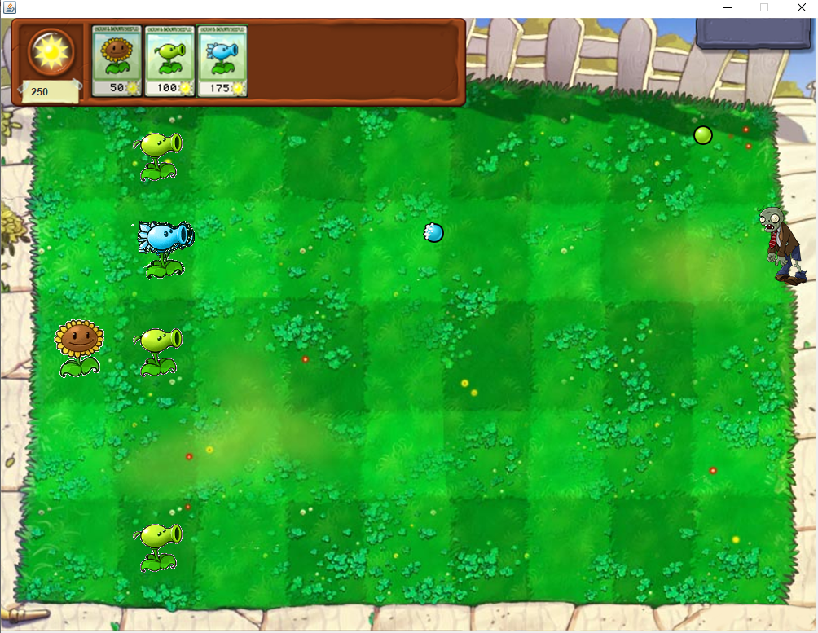

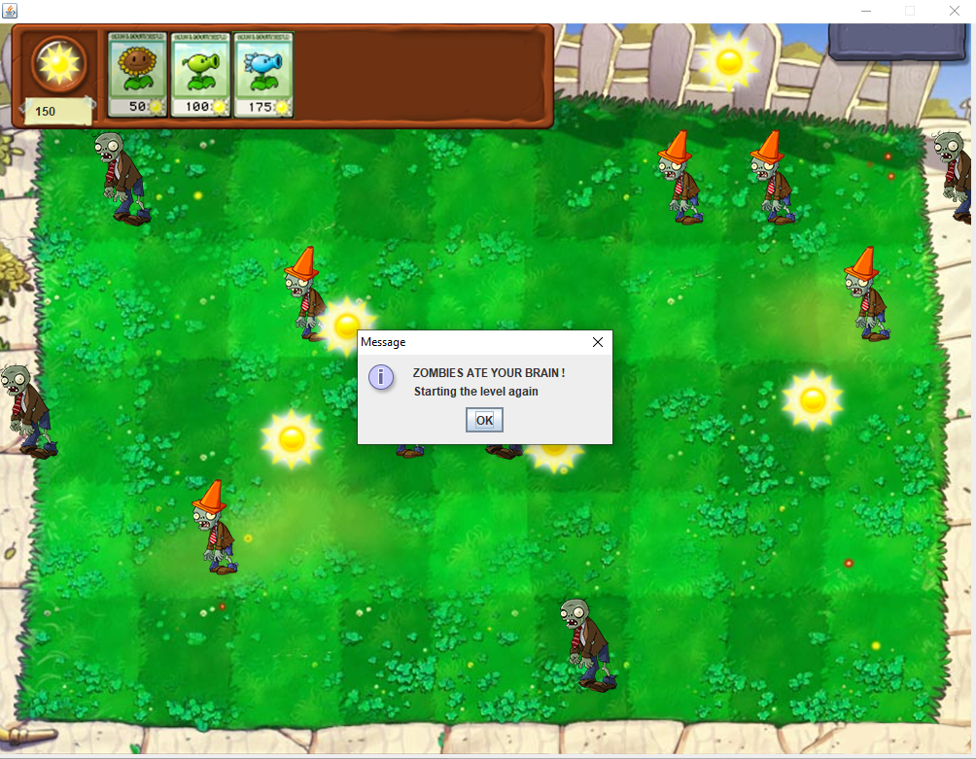

IV/ References

<https://viettuts.vn/java-awt/mouselistener-trong-java-awt>

<https://viettuts.vn/java-swing/mouse-listener-trong-java-swing>

<https://www.javatpoint.com/super-keyword#:~:text=The%20super%20keyword%20in%20Java,referred%20by%20super%20reference%20variable>.

<https://www.javatpoint.com/java-swing>